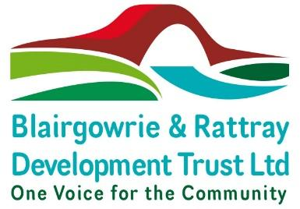**NOTICE OF ANNUAL GENERAL MEETING 2024**

**Blairgowrie Town Hall**

**At 6pm on Monday 25th November 2024**

Notice is hereby given that the 7th Annual General Meeting of The Blairgowrie & Rattray Development Trust will be held at Blairgowrie Town Hall at 6pm on Monday 25th November 2024

Business to be dealt with at the meeting is:

1. Welcome and apologies
2. Minutes of AGM 20th December 2023 - Approval
3. Presentation of the Annual Trustees Report & Accounts
4. Proposal of Resolutions:

As Ordinary Resolutions

* 1. To re-elect Robert Swan as a director

Appointment of Co-opted directors:

* 1. To appoint Robert Brawn as a director
  2. To appoint Laura Gardiner as a director
  3. To appoint Peter Thomason as a director
  4. To appoint Leith Hill as a director

1. Presentation on plans for 2025

Close

**A member of The Blairgowrie & Rattray Development Trust Limited (“the Company”) eligible to attend and vote at the Members’ Meeting is entitled to appoint another person as proxy to attend and vote on a poll in their place.**

**A form of proxy is enclosed and must be lodged at the Company’s registered office at least 48 hours before the meeting.**