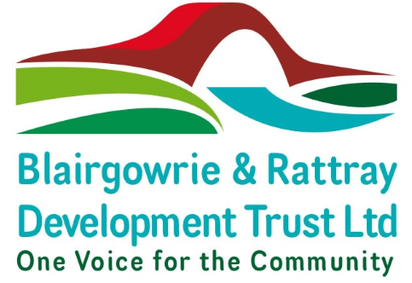

**DRAFT Minutes of the 6th Annual General Meeting of Blairgowrie & Rattray Development Trust Limited**

**Held in Rattray Bowling Club on Wednesday 20th December 2024 at 6pm**

**Present:** Teresa Donaldson – Director & Chair, Len Seal - Director, Linda Tait - Director, Bob Swan - Director & Treasurer

# In attendance

Trust ordinary members - twelve

Non–members in attendance – fourteen

S Johnson - Development Officer

L McDonald - Operations Officer

R Lamond - Operational Support

1. **Welcome & Apologies** – Teresa Donaldson welcomed everyone. Apologies were recorded as follows: Tracie Dick, Liz Mason, Jacqueline & John Edwards, Jessie Shaw, Barbara & Michael Stevenson, Pauline Cropper, Kate Davies, Pat Richards, Rose Patterson

1. **Approval of Previous Minutes –** The minutes 5th BRDT AGM held on 16th October 2022 were approved. Proposed by B Swan, Seconded by I Richards.

1. **Reports & Accounts Presentation –** These had been made available prior to the AGM and were accepted by all with no questions raised. S Johnson & L McDonald provided a summary of activity over the year and thanked everyone for their contribution in particular the many volunteers who supported all projects.

The accounts were Proposed by L Seal and Seconded by L Tait.

The Accounts were approved.

# 4. Proposal of Resolutions

The Development Officer announced the Resolutions and confirmed that 8 Proxy Forms had been received all supporting the resolutions or agreeing the Chair to cast their vote as they see fit:

4.1 To update the Articles Content List. Proposed by S Nichol, seconded by B Swan and passed unanimously.

4.2 To amend membership to free renewed annually with those already lifetime members to remain for life or until they opted out. Proposed by I Richards, seconded by L Tait and passed unanimously.

4.3 To amend Article 101 typo. Proposed by W Wilson, seconded by S Nichol and passed unanimously.

4.4 To appoint L Seal as a Director. Proposed S Nichol, Seconded B Swan and passed unanimously.

## 5.0 Appointment of Co-opted Directors as per Articles 83-84

5.1 To appoint T Dick as a Director. Proposed by S Nichol, seconded by I Richards and passed unanimously.

5.2 To appoint L Tait as a Director. Proposed by W Wilson, seconded by S Nichol and passed unanimously.

## 6.0 Any Other Competent Business

6.1. I Richards suggested BRDT needs to promote itself more and put signs on the BaRI Building showing BRDT owned it. L McDonald advised there are signs planned but we are waiting for the painting to be completed. To be taken forward via Board Mtgs.

6.2. A Shaw asked about the use of Rattray Community Connect and it’s availability for the public. H Harris advised it had received funding as part of the Rattray Regeneration initiative to provide a Community space but it is not available for the Community. C Shiers advised it was being used by housing due to issues with their old accommodation but it is available for rent. There were comments that rent is quite expensive. I Richards commented that the Community Campus is a great facility but underused. BRDT would liaise with Blairgowrie & Rattray Community Council and ask PKC what the plans were with Rattray Connect. To be taken forward via Board Mtgs.

6.3. BRDT intended asking the public about the future of the Blairgowrie Public Toilets and asked those present to complete the survey they had provided. To be taken forward via Board Mtgs.

## 7.0 Close

The Annual General Meeting closed at 6.46pm with the date of the next AGM TBC.